To help you make your submission please follow the instructions below or click here for a step-by-step instructions. You can also cut and paste the information below or make amendments as you see fit. What to do:
STEP 1:
Click on this link here or go to https://pica.asn.au/wp-content/uploads/2019/12/My-Tenancy-QLD-Reform-Submission.docx to open your word submission document. Give it a name- ie “John Smith’s submission form” and add your name to the bottom of the submission. Save it in your computer.

STEP 2:
Click on this link https://www.yoursayhpw.engagementhq.com/give-feedback-renting-in-qld/survey_tools/written-submissions-renting-in-qld

STEP 3:
You’ll need to create an account for the submission. Click on “Register”
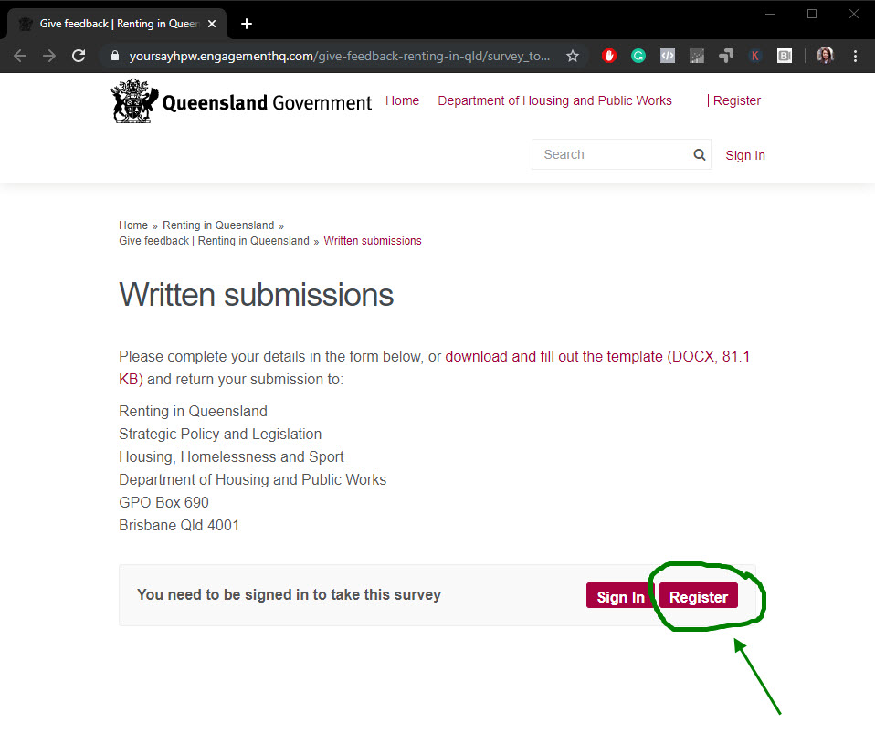
STEP 4:
Fill in the Registration form and click “Register”.
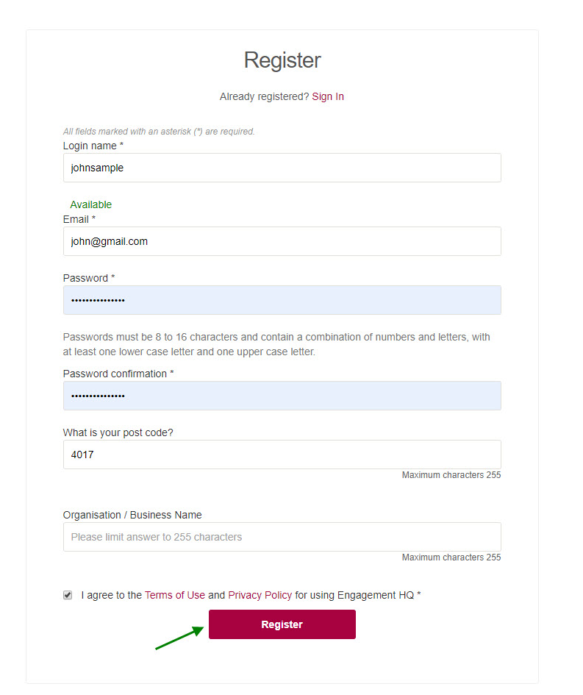

Step 5:
You’ll need to activate your account. Log in to your email and click on the link provided. Make sure to check your spam folder.
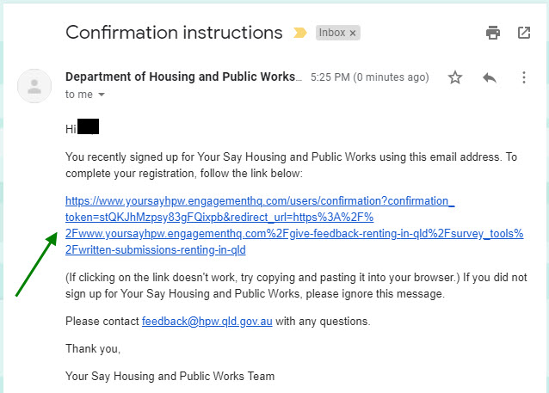

Step 6:
You’ll be redirected to a confirmation page. Click on “Continue”

STEP 7:
You’ll start to see a series of fields. Here’s a sample of PICA’s submission.
Can we publish this submission on our website?
Yes
Which module is this submission relating to?
Renting with pets
Minimum Housing Standards
Ending tenancies fairly
Minor modifications
Do you agree with the recommended option/s presented in the Regulatory Impact Statement? If not, which option/s do you prefer?
No, I disagree with the recommended options presented in the Regulatory Impact Statement. For all the modules selected above, I would support Option 1 (Status Quo) but at the same time, a more balanced conversation between tenants and property owners should be started. Please refer to my submission attached.
Are there any other options that should be considered?
No. Please refer to my submission attached.
Do the recommended option/s provide a balance between the rights of property owners and the rights of tenants?
No, it does not provide a balance between the rights of property owners and the rights of tenants. Please refer to my submission attached.
What are the benefits to you if the recommended option/s are implemented?
There are no benefits to me. Please refer to my submission attached.
Are there any costs to you if the recommended option/s are implemented?
Yes there will be cost for me, the property owner as well as the tenants. Please refer to my submission attached.
Are there any other factors relating to the proposed changes that have not been recognised or considered in the Regulatory Impact Statement? If so, what are they?
Yes, please refer to my submission attached.
Is there anything else you want to tell us about the Regulatory Impact Statement?
Yes, please refer to my submission attached.
Step 8:
On Question 15, click on “Choose file…” and look for the submission form that you’ve saved on your computer. Click on “Open” and that will attach the file.

Step 9:
Click on “Submit”

